WATER AND WATER ACTIVITY
1. Give definition of bound water.
2. Give definition of water activity (formula) and point out the value of water activity below which there is no microbial development.
3. Define and draw the zones in the moisture sorption isotherms (directly on the diagram below). What is the name of the difference in the pathways of the adsorption and desorption curves?
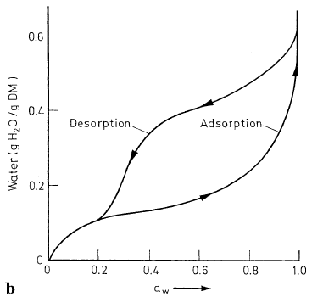
4. At which value of the water activity the Maillard reaction has greatest speed?
5. Name the types of interaction of water molecules with other substances. Which interaction is the strongest?
CARBOHYDRATES
1. Which monosaccharide is presented : ( ! NB – there might be other monosaccharides in this type of questions according to the schemes of the aldoses and ketoses – Carbohydrate presentations)
a). D-fructose;
b). D-galactose;
c). D-ribose;
d). L-saccharose.
2. Which monosaccharide is presented :
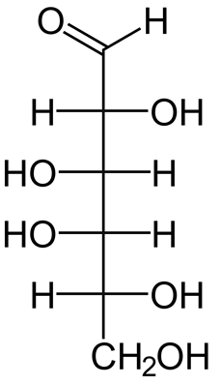
a). D-fructose;
b). D-galactose;
c). D-mannose;
d). L-saccharose.

3. Circle the anomeric (glycoside) hydroxyl group in the formula below.

4. Describe (by using formulae) the reaction of glucose with NaHSO₃. What is the importance of the reaction?
5. Give the classification of the polysaccharides according to configuration of the hydroxyl groups which participate in the bonding (equatorial or axial)?
6. Industrially pectin is used as:
a). preservative;
b). sweetener;
c). jellifying agent;
d). it is not used industrially.
LIPIDS
1. Define the ω-3 and ω-3 fatty acids.
2. Why the lipids are hydrogenated and what is the drawback of the process?
3. Which fatty acids have the higher melting point – the saturated or unsaturated?
4. Acylglycerols are :
a). ethers of isoprene;
b). esters of fatty acids and glycerol;
c). esters of fatty acids with sphingosine containing carbohydrates;
d). none of the above.

MAILLARD REACTION
1. How many stages are recognized in the Maillard reaction?
2. In the first stage (first reaction) of the Maillard reaction which compounds are formed?
3. Which are the products of the Strecker degradation?
4. Which amino acid is the most reactive in the Maillard reaction?
5. Name two possible ways of Miallard reaction inhibition.

THERMAL TRANSFORMATIONS OF AMINO ACIDS AND PROTEINS; VITAMINS – STABILITY AND THERMAL TRANSFORMATIONS

1. Which compounds are formed as a result of racemization of L-amino acids (especially in alkaline medium)?
2. Write down two roles of vitamins in the organisms.
3. Give the name of the compound which is formed when vitamin C (dehydroascorbic acid) participates in the Strecker degradation.
4. How many isomeric forms of ascorbic acid do you know?

AUTOXIDATION AND THERMAL-OXIDATIVE DESTRUCTION OF LIPIDS
1. Point out the stages of autoxidation of lipids.
2. Oxygen in which state is responsible for beginning of autoxidation reactions of lipids?
3. At which value of water activity lipid autoxidation has the lowest speed?
4. Give the names of two methods for measuring lipid oxidation.
5. Give the name of one antioxidant and explain the mechanism of action of the antioxidants.
6. Why the refined oils are more suitable for frying than unrefined oils?
CARAMELIZATION
1. How many type of caramel do you know?
2. Which type of caramel is the most used industrially?
3. Give the name of the following compound (important intermediate in the caramelization and Maillard reactions):

FLAVOR
1. Write down the names of the 5 tastes and at least two sensations (feelings in the mouth).
2. Write down the definition of aroma value.
3. What is off-flavor?

