Personal statement
A personal statement should consciously try and answer the following questions: who you are, what you can offer, and what you aim for in your career.

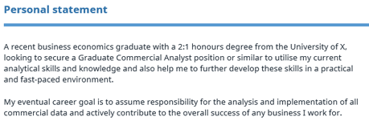
How to write a personal statement
Personal statement: Dos and don’ts
Personal statement examples

Education
Education should generally be the focus of a Graduate CV. Write in reverse-chronological order, with the most recent events coming at the top.
Include your degree classification and any other higher education diplomas. In direct terms, particular course modules you’ve undertaken may be relevant to a role or scheme you’re applying for and should be used to demonstrate your wider knowledge of the subect.
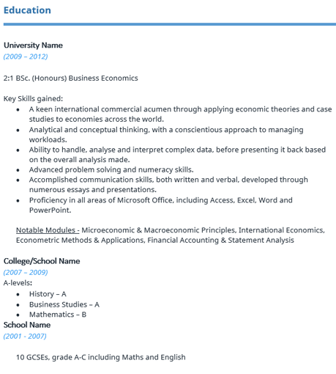
Which parts of my education should I include in my CV?

Hobbies & Interests
A Hobbies and Interests section is optional. If they’re particularly individual, or actually back up your motives for applying for this role, then they should be included.
Ask yourself: Will they help you get the job? Socialising with friends and going to the cinema, for example, will probably be of little interest to the employer.
Finally, make sure you’re happy to expand upon them during your interview if called upon.
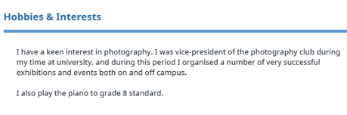
Should I include hobbies and interests in my CV?

Employment history
Chances are, you may not have that much previous work history to include here, and if you do it may not all be relevant. If this is the case, feel free to be brief.
After stating your dates of employment, company name and job title, putting a few top line duties and achievements will generally suffice. However, wherever possible, try and demonstrate your success in practical ways.
Not only will they help quantify your output, they will also help validate your awareness of meeting targets/key responsibilities.
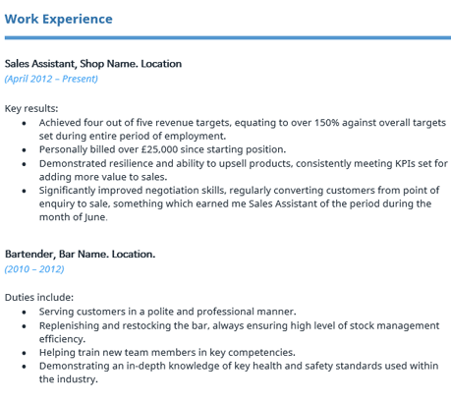
How to get work experience
How to find a new job

